**DAMPING EFFECT DUE TO THE PERFORATED SHIMS IN THE JOURNAL BEARING**

A Project Report Submitted to



**Visvesvaraya Technological University, Belagavi**

in partial fulfilment of requirements of

VIII semester Project work (Phase II) - 16ME8DCPW2

of

BACHELOR OF ENGINEERING in MECHANICAL ENGINEERING

Submitted by

|  |  |
| --- | --- |
| **R RAJESH KUMAR**  **RAJU S**  **SANJAY K** | **1BM15ME124**  **1BM15ME131**  **1BM15ME145** |

Under the guidance of

Dr. G. SARAVANAKUMAR

Assistant Professor

Department of Mechanical Engineering



**Department of Mechanical Engineering**

(Accredited by NBA, under Tier 1, 2014-2019)

**B. M. S. COLLEGE OF ENGINEERING**

(Autonomous Institution Affiliated to Visvesvaraya Technological University, Belagavi)

PB 1908, Bull Temple Road, Bengaluru – 560 019

May- 2019

**B. M. S. COLLEGE OF ENGINEERING**

PB 1908, Bull Temple Road, Bengaluru – 560 019



Department of Mechanical Engineering

***Certificate***

Certified that the project entitled **DAMPING EFFECT DUE TO THE BUMPS**

**IN THE COMPLIANT JOURNAL BEARING** is a bonafide work carried out by

|  |  |
| --- | --- |
| **R RAJESH KUMAR**  **RAJU S**  **SANJAY K** | **1BM15ME124**  **1BM15ME131**  **1BM15ME145** |

in partial fulfillment for the award of Bachelor of Engineering in Mechanical Engineering of the Visvesvaraya Technological University, Belgaum, during the year 2018– 19. It is certified that all corrections / suggestions indicated for internal assessment have been incorporated in the report deposited in the departmental library. The project report has been approved as it satisfies the academic requirements in respect of Project Work Phase – II (16ME8DCPW2) prescribed for the said degree.

Signature of Guide Signature of HOD

(Dr. G. Saravanakumar) ( Dr. Rudra Naik)

Signature of Principal

Semester End Examination

Name of the Examiners Signature with Date

1.

2.

**Declaration**

We hereby declare that the project work entitled **DAMPING EFFECT DUE TO THE BUMPS IN THE COMPLIANT JOURNAL BEARING** has been independently carried out by us at Department of Mechanical Engineering, under the guidance of Dr. G. Saravanakumar, Department of Mechanical Engineering, B. M. S. College of Engineering, Bengaluru, in partial fulfilment of the requirements of the degree of Bachelor of Engineering in Mechanical Engineering of Visvesvaraya Technological University, Belagavi.

We further declare that we have not submitted this report either in part or in full to any other university for the award of any degree.

|  |  |  |
| --- | --- | --- |
| **R RAJESH KUMAR**  **RAJU S**  **SANJAY K** | **1BM15ME124**  **1BM15ME131**  **1BM15ME145** |  |

Place: Bengaluru

Date: 24th May 2019

**Acknowledgment**

**Guide**: Dr. G. Saravanakumar, Assistant Professor, Department of Mechanical Engineering, B. M. S. College of Engineering, Bengaluru

**Project Coordinators**: Prof. Ramesh K., Assistant Professor, and Dr. R. N. Ravikumar, Assistant Professor, Department of Mechanical Engineering, B. M. S. College of Engineering, Bengaluru

**Head of the Department**: Dr. Rudra Naik, Professor & Head, Department of Mechanical Engineering, B. M. S. College of Engineering, Bengaluru

**Principal**: Dr. B. V. Ravishankar, Principal, B. M. S. College of Engineering, Bengaluru

**Abstract**

In 21st century, a lot of research is going on journal bearing. Shafts are of great significance in power transmission and it must be supported by bearings. Journal bearing is widely used in almost all automobile and aerospace industries because of its versatility in supporting and applying the load on the shaft by reduced friction. This project work mainly investigates about the damping effect in the compliant journal bearing and aims at calculating the performance parameters in it. Also, the effective control of vibration in shafts due to the increased load carrying capacity when the bump of damper foil is placed in it. Numerous modern researches mainly focus on computing the oil flow in the journal bearing using Navier stokes and Reynold’s equation. The modified Reynolds Equation can be solved by Numerical Methods with appropriate boundary condition. This project uses the finite difference method to calculate the distribution of hydrodynamic pressure in the compliant journal bearing. Finite element method tends to compare the forces, stresses and strains developed in the system with the help of equations writing them in matrix form while in Finite difference method we change the derivatives or gradients by simple difference formula. Basically, these are just the two alternate methods for discretization process. In this method the entire bearing space is divided into an M*N grid system. The pressure values at every node is initialized with certain value, subsequently on every iteration the pressure values are updated. Although the numerical methods for solving the Reynold’s equation are accurate and efficient enough for arriving at the result, this project aims at the MATLAB solution of Reynolds equation when the journal rotates in the fluid medium supported by bearing. The way of creating a computer program based on the theory of hydrodynamic lubrication announced by Reynolds is discussed.

Keywords: Tribology, Reynold’s equation, Perforated shim, Computer program, Numerical methods.

**Nomenclature**

|  |  |  |
| --- | --- | --- |
| **e** | : | Eccentricity of shaft (mm) |
| **θ** | : | Coordinate along the circumferential direction (degrees) |
| **ω** | : | Angular speed of rotation (rpm) |
| **ϕ** | : | Attitude angle (degrees) |
| **h** | : | Fluid film thickness (mm) |
| **W** | : | Load carrying capacity (N) |
| **s** | : | Bump pitch (mm) |
| **t** | : | Thickness of the foil (mm) |
| **l** | : | Half bump length (mm) |
| **u** | : | Velocity component in x direction (mm/s) |
| **v** | : | Velocity component in y direction (mm/s) |
| **w** | : | Velocity component in z direction (mm/s) |
| **c** | : | Radial clearance (mm) |
| **d** | : | Diameter of the shaft (mm) |
| **E** | : | Modulus of elasticity (N/mm2) |
| **L** | : | Length of bearing (mm) |
| **r** | : | Radius of shaft (mm) |
| **α** | : | Compliance Number or Bearing Number  of bearing (dimensionless) |
| **υ** | : | Poisson‟s Ratio of Lubricant (dimensionless) |
| **ρ** | : | Density of gas used in bearing (kg/m3 |
| **η** | : | Coefficient of viscosity of bearing (N-s/mm2) |
| **ef** | : | Eccentricity of foil bearing (mm) |
| **τ** | : | Shear stress acting on the control volume (N/mm2) |
| z | : | Non dimensional length along z direction (dimensionless) |
| p | : | Non dimensional pressure (dimensionless) |
| h | : | Non dimensional film thickness (dimensionless) |

**Table of Contents**

|  |  |  |
| --- | --- | --- |
| **Certificate** | | **1-2** |
| **Declaration** | | **3** |
| **Acknowledgement** | | **4** |
| **Abstract** | | **5** |
| **Nomenclature** | | **6** |
| **Table of content** | | **7** |
| **List of figures** | | **8** |
| **Introduction** | | **9-10** |
| **Literature Survey** | | **11-16** |
| **2.1** | **Parts of Journal Bearing** | **11** |
| **2.2** | **Regimes of lubrication in Journal bearing** | **12** |
| **2.3** | **Literature Papers** | **12** |
| **2.4** | **Damping effect in Journal bearing** | **14** |
| **2.5** | **Concept of converging film** | **15** |
| **2.6** | **Approach to the solution** | **15** |
| **3** | **Methodology: Derivation of Reynold’s equation** | **18** |
| **4** | **Results and discussion** | **38** |
| **5** | **Application** | **40** |
| **6** | **Conclusion** | **41** |
| **7** | **References** | **42** |

**List of figures**

|  |  |  |
| --- | --- | --- |
| **Figure No.** | **Description** | **Page No.** |
| 1 | Bump foil | 10 |
| 2.1 | Journal Bearing | 11 |
| 2.2 | The clearance between Journal and bearing when loaded | 12 |
| 2.3.1 | Loads acting on bearing | 14 |
| 2.3.2 | Sectional view of bump | 14 |
| 2.5 | Converging oil film | 15 |
| 2.6 | Nodal points used in FDM | 16 |
| 3.1 | Forces applied on a control volume in the bearing | 18 |
| 3.2 | Pressure profile | 23 |
| 3.3 | Bumps acts as springs | 24 |
| 3.4 | Pressure profile for whole bearing | 34 |
| 3.5 | Pressure profile for single bump | 34 |
| 3.6 | Variation of film thickness | 35 |
| 4 | Graphs | 38 |
| 5.1 | Cryogenic Turbo expander | 40 |

**Chapter 1**

**Introduction**

Shaft bearings are generally classified according to the direction in which the applied load is supported by the bearing relative to the axis of the shaft. If the bearing supports the load in the radial direction it is called journal bearing. The shaft member of this bearing is called journal and the cylindrical body around the journal is called bearing. Sometimes both parts of the bearing unit rotate, and sometimes the journal has a rotating motion, while the bearing has an oscillating motion relative to the shaft as in case of the connecting rod bearing and the crank pin of a piston engine or a piston compressor. Currently large number of journal bearing principles are in mechanical components like machine tool, turbo-machine, connecting rod piston and automotive shafts.

Journal bearings play a prominent role in applying and supporting the load acting on the shaft in almost all automotive and aerospace industries because of its numerous functions like oil acts as lubricant preventing wear, oxidation and corrosion. Journal bearings are considered to be a vital component of all rotating machines. In this, bearing oil is introduced between the journal and bearing which provides sufficient pressure build up to support the load when optimum speed(rpm) is reached. In general, bearing is a machine part whose function is to support a secondary member, preventing its motion in the direction of an applied load but at the same time allowing motion in another predetermined direction.

More often, it is very important to look deeply into the performance characteristics of bearings and this project mainly aims at normalizing the Reynolds equation to calculate effective damping when the perforated shims are placed. Reynolds, a great scientist has made significant contributions

* He showed the importance of fluid film lubrication, viscosity of a lubricant on the frictional characteristics, and radial clearance.
* He derived the differential equation for the pressure distribution in the oil film. This become the basic equation in the hydrodynamic theory of lubrication.

Normalizing the modified Reynolds equation computes the normalized form of the n-th order linear ordinary differential equation, thereby calculating the amount of energy dissipated when the fluid flows between perforated shims.

**1.1 Advantages of Compliant Nature of Bearing**

* A unique advantage of compliant materials is that they have a certain degree of elastic self-aligning.
* The advantage of surface compliance is that it relaxes the requirement for high precision which involves high cost.
* The compliant surfaces usually have better wear resistance.
* Elastic deformation prevents removal of material due to rubbing of rough and hard surfaces. Compliant materials allow the rough asperities to pass through without any wear.
* Rubber sleeves are often used with slurry lubricant in pumps

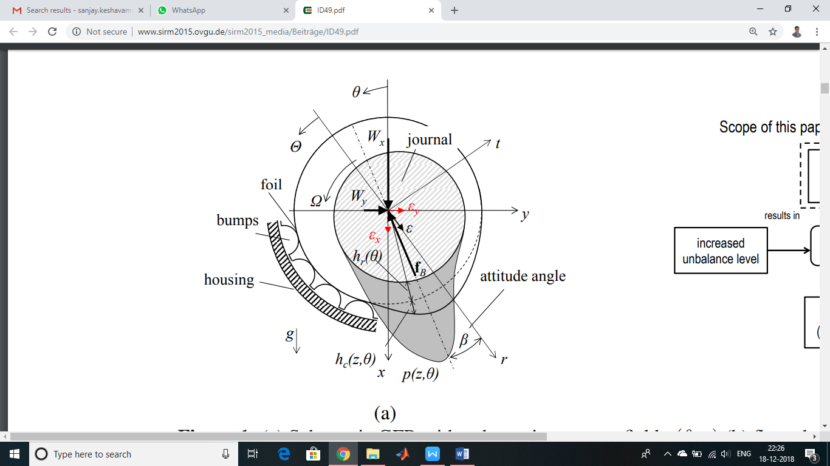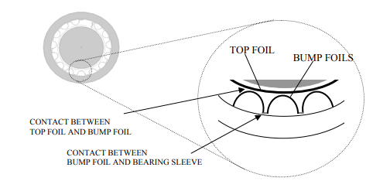**1.2 Physical Look:**

Fig 1.2: Bump foil

The above figure shows the overall look of a compliant journal bearing. As opposed to a conventional journal bearing, it consists of an outer bearing sleeve or an outer housing which contains a round series of bumps over a thin foil strip. A thin smooth top foil sheet is placed over the bump foil. Now these foils are connected mostly by welding at one of the ends known as the leading edge and are open at the other end called the trailing edge. The uniqueness of a compliant journal bearing over any other conventional bearing is the fact that the bump supports the top foil and act as a spring, hence the bearing is known as compliant over the bump foil. Now these foils are connected mostly by welding at one of the ends known as the leading edge and are open at the other end called the trailing edge. The uniqueness of a compliant journal bearing over any other conventional bearing is the fact that the bump supports the top foil and act as a spring, hence the bearing is known as compliant. The journal has an interference fit with very negligible clearance, as a result the journal and the foils are in metal to metal contact when the shaft is stationary but as soon as a critical lift-off speed is achieved the journal rotates on a thin gas film due to the hydrodynamic pressure developed. As a result of this hydrodynamic pressure the top foil deforms and forces it away from the shaft towards the bump strip.

The application of forces, which act perpendicular to direction of rotation of shaft, is shown in figure. The hydrodynamic pressure is a function of operating speed and thus influences the deformation of foils. Thus in a nutshell we can say that the film thickness varies with the hydrodynamic pressure as well as the physical, rather elastic properties of the foils. The clearance in radial direction in this type of bearings also represents important criteria which influences the overall performance of the bearing.

**Chapter 2**

**Literature Survey**

**2.1 Parts of Journal bearing**

Journal bearings are also called as sleeve bearings or plane bearings. The basic function of a journal bearing is to support a shaft. This type of bearing is usually chosen for applications that are not subject to changes in shaft speed or load. There are three major components of this type of system: the stationary part or the bearing, the moving part or the journal, and the lubricant. The system’s metal components may consist of any number of materials. The bearing normally is made of a softer metal than that of the journal to prevent wearing of the moving element. The lubricant enters the bearing from the centre and passes through to the ends where it leaves the bearing. The lubricant performs several functions including providing controls for friction, wear, corrosion, temperature and contamination, as well as a power transmission component.

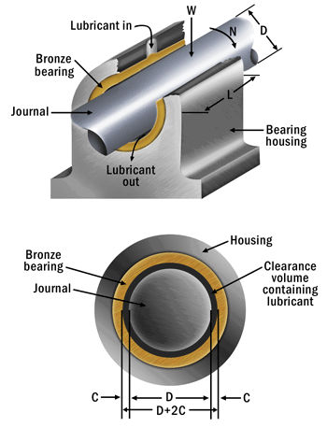

Figure 2.1: Journal Bearing

**2.2 Regimes of lubrication in Journal bearing**

In journal bearing lubrication, three basic lubrication regimes apply: hydrodynamic or full film, mixed film, and boundary. It is important to note that regardless of how well a metal surface is machined, imperfections still exist. These little peaks and valleys are known as asperities. The three lubrication regimes essentially refer to the amount of contact between these asperities.

The vast majority of journal bearings are designed to operate in the hydrodynamic (full-film) regime. However, these bearings spend a portion of their operating life in the other two regimes as well. Boundary Lubrication is defined as lubrication by a liquid under conditions where the solid surfaces are so close together that appreciable contact between opposing asperities is possible. In short, boundary lubrication is the regime where metal-to-metal contact occurs and the largest portion of wear is generated. The vast majority of the load is being carried by these asperities with very little, if any, being carried by the lubricant. This typically takes place upon equipment start up. In mixed-film lubrication, a little contact between the asperities still exists, but the lubricant also supports some of the load. This happens shortly after start up but prior to reaching normal operating speed. Mixed-film lubrication is described as part of the total load carried by the bearing is being supported by individual load-carrying pools of self-pressurized lubricant and the remaining part by the very thin contaminating film associated with boundary lubrication.



Figure 2.2: The clearance between Journal and bearing when loaded

Once the normal operating speed is reached, full-film or hydrodynamic lubrication is achieved. In this regime, the two metal surfaces are separated by a lubricant film to such a degree that the asperities no longer come in contact. It makes perfect sense that if you maintain full separation of the metal surfaces with a lubricant in between, no mechanical wear will occur. In fact, it has been stated that as long as this condition exists, these bearings can operate indefinitely without wear.

Fluid pressure is generated in the lubricant film, which is able to support load due to its viscosity. Lubricating oils have a significant pressure-viscosity coefficient. This means that the greater the pressure on the lubricant, the higher the viscosity at the pressure point. The pressure-viscosity coefficient is what provides the load-carrying capacity of a journal bearing.

**2.3 Literature Papers:**

**2.3.1 Stefano Morosi, Ilmar F.Santos**

The authors published a paper to lay the theoretical basis for application of active control to gas lubricated journal bearings. The present motivation behind the paper is to demonstrate the degree to which application of active lubrication to gas journal bearings is feasible. The basic principle lies in generation of active forces. This is obtained by regulating the injection of lubricants in radial direction with the help of piezoelectric actuators which are clamped on the back of bearing sleeves. The authors also developed a mathematical model which couples the dynamics of rotor bearing system with the dynamics and mechanics of the actuators through a simple proportional derivative feedback system. The main advantages are the notable reduction in the synchronous vibration, effective addressal of the half frequency whirling motion. It was also proved that this type of bearing improves transient response characteristics, and thus has a better capability of responding to sudden shocks and excitations which the entire system may be subjected to. Due to the addition of active lubrication several new parameters and variables are added to the analysis of the system.

**2.3.3 D.Kim, S.Park**

The author started by recognizing one of the most critical issues surrounding the reliability of the foil bearings which is a coating wear on the top foil and rotor during the starting and stopping of bearings. Also cooling is sometimes very important under certain applications because the foil bearings can lead to generation of considerable amount of heat depending particularly upon the operating conditions. The space between the top foil and the bearing sleeve is filled with axial flow in most of cases. This thesis introduces a hybrid foil bearing with external pressurized. The advantage of the hybrid nature leads to elimination of coating wear during start/stop of bearings. Also it leads to reduction of the drag torque during start-up. Further a hybrid system does now require any cooling system

**2.3.3 Sebastien Le Lez, Static and dynamic characterization of a bump type bearing structure**

The performance of gas foil bearings (GFBs) relies on a coupling between a thin gas film and an elastic structure with dissipative characteristics. Because of the mechanical complexity of the structure, the evaluation of its stiffness and damping is still largely inaccurate if not arbitrary. The goal of this paper is to improve the understanding of the behaviour of the bump type FB structure under static and dynamic loads. The structure was modelled with finite elements by using a commercial code. The code employed the large displacements theory and took into account the friction between the bumps and the support and between the bumps and the deformable top foil. Static simulations enabled the estimation of the static stiffness of each bump of a strip.

**2.3.4 Daejong Kim, Soongook Park**

This research paper throws light on the design; construction and testing of the first air foil bearing abbreviated as HAFB. It was compared with its hydrodynamic counterpart. The hybrid case was noticeable with much higher load capacity and much less air consumption. These two factors are particularly advantageous in terms of efficiency and cooling capacity. Also the direct injection of air leads to minimization of thermal distortion of the rotor. Another factor was that the starting torque in hybrid bearings was much lower than the friction torque under steady state operation of hydrodynamic bearings which helps to eliminate the wear problem.

**2.3.5 Hou Yu, Chen Shuangtao, Chen Rugang, Zhang Qiaoyu, Zhao Hongli**

In this paper a numerical model was developed which coupled the hydrodynamic pressure of the lubricant film with the deformation of the foil structure. In this model the lubricant was taken as isothermal and isoviscous. And these properties were put to linearize the Reynolds Equation. The top foil was designed in the form of a strip of rectangular thin plate which is supported at a rigid point. The pressure distribution, film thickness and deformation of foil were solved with the help of Finite Element Method. Finally the influence of several parameters like eccentricity ratio, bearing number and number protuberances on performance and life of bearing was studied. The results showed that bearing characteristics are change significantly with increase in the bearing number and eccentricity ratio. Also the hydrodynamic pressure as well as the load capacity as found to be enhanced for this new type of bearing since the top foil with considerable lines of protuberant support tends to warp upwards at the bearing sides due to the bending stresses. This upward warp may lead to negative film thickness for large eccentricity ratio which represents ill-working of the bearing.

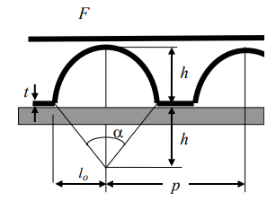

Fig 2.3.1: Sectional view of bump

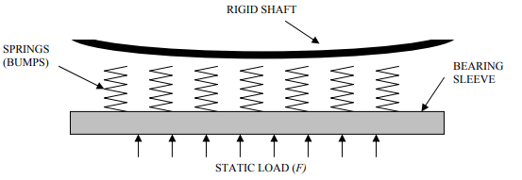**2.3.6 Oscar De Santiago, Luis San Andres**

Fig. 2.3.2. Loads acting on bearing

Absence of lubricant introduces the possibility of designing the bearings within the flow path of thermal machines. The process gas could also be used as the working fluid for the bearing. Recent work in the area of foil bearing technology shows that there are calibrated models which help us to accurately predict the performance of the bearings of non-conventional sizes. The main focus of this research work is to make a note of all the parameters of foil bearings which affect the static and dynamic performance and calibrate them for the industrial applications. This is done through a computational model, as a result of which a study on the use of gas foil bearings in a centrifugal compressor for industrial purposes has been done. The first area of investigation suggests that the nonlinear effect of contact between the bumps and the top foil as well as the bumps and carrying sleeve could overtake the response of the bearing thus making the analysis inadequate. The second area of investigation throws light on the fact that this type of bearing has only a limited dynamic stiffness which when combined with the minimum film thickness provides with a load capacity of a few Newton. The dynamic load capacity is directly proportional to the linear response of the bearing. The macro mechanism which has been provided determines the load capacity according to the overheating of the top foil. Aging, fretting, pitting, wearing, fatigue etc. of the bump foil are some of the other characteristics which put a limit on the applicability of the foil bearings.

**2.4 Damping effect in Journal bearing**

The primary advantage of a fluid film bearing is often thought of as the lack of contact between rotating parts and thus, infinite life. In a pure sense, this is true, but other complications make this a secondary reason for using these bearings. During start up there is momentary metal-to-metal contact and foreign material in the lubricant or excessive vibration can limit the life of a fluid film bearing. For these reasons, special care must be taken when selecting and implementing a lubrication system and special vibration monitoring techniques must be applied. The most important aspects of the health and longevity of a fluid film bearing are proper selection, proper installation, proper lubrication, and the alternating hydrodynamic loads imposed on the bearing surface by relative shaft-to-bearing vibration. The primary advantage of fluid film bearings is it provides damping. Damping is required in order to pass through a critical speed. Damping is also required to suppress instabilities and synchronous vibration. Damping provides ability to withstand shock loads and other abuse, reduce transmitted vibration and noise. It also provides long life under normal load conditions.

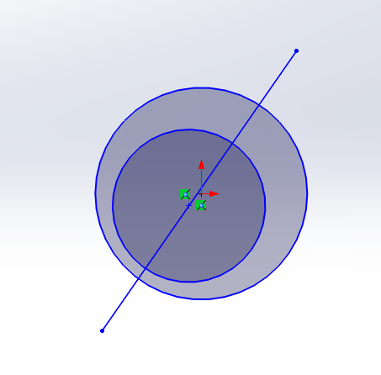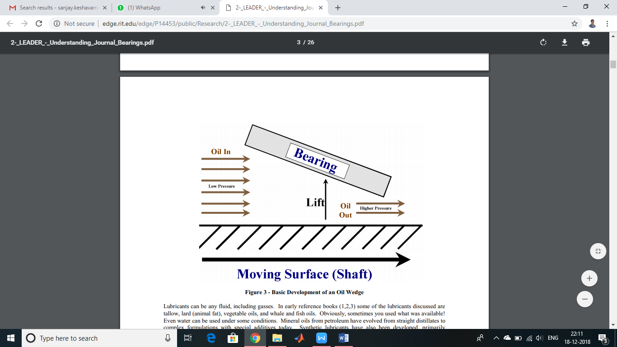**2.5 Concept of converging film:**

Figure 2.5: Converging oil film

In infinitely short (narrow) hydrodynamic journal bearings, the length of bearing in axial direction is very short. Hence, there is considerable flow of fluid in an axial direction of Z-direction i.e, dp/dz & dp/dx. In such bearings, the pressure gradient in an axial direction or Z-direction much higher than the pressure gradient in X-direction. Hence in infinitely short (narrow) hydrodynamic journal bearings, the pressure gradient in X-direction is neglected. dp/dx = 0.

**2.6 Approach to the solution**

Equations can be solved analytically but due to the fact that there may be many of them, they may be complicated and difficult to solve (nonlinear partial differential equation). Numerical methods which give approximate required solution are used. Appropriate software allows to obtain numerical solutions of equations representing mathematically formulated engineering problems. The basic methods of calculation used in computer programs are: Finite Difference Method (FDM), Finite Element Method (FEM), Finite Volume Method (FVM). The main differences between these methods are way of finding a solution, defining boundary conditions and method of analysis. In this project work, Finite Difference Method is used for solving the Reynolds Method. The fundamental difference between Finite Difference Method and Finite Element Method is that in finite element method we tend to compare the forces, stresses and strains developed in the system with the help of equations writing them in matrix form while in Finite Difference Method we change the derivatives or gradients by simple difference formula. Basically, these are just the two alternate or optional methods for discretization process. In this method the entire bearing space is divided into an M*N grid system. The pressure values at every node is initialized with certain value, subsequently on every iteration the pressure values are updated. This method involves approximations that replace the derivatives procured from the differential equations into the finite difference equation that is approximation of differential equations into difference quotients. These approximations, in algebraic form are associated with each value of the dependent variable in the point of the solution area with values in a number of neighbouring points.

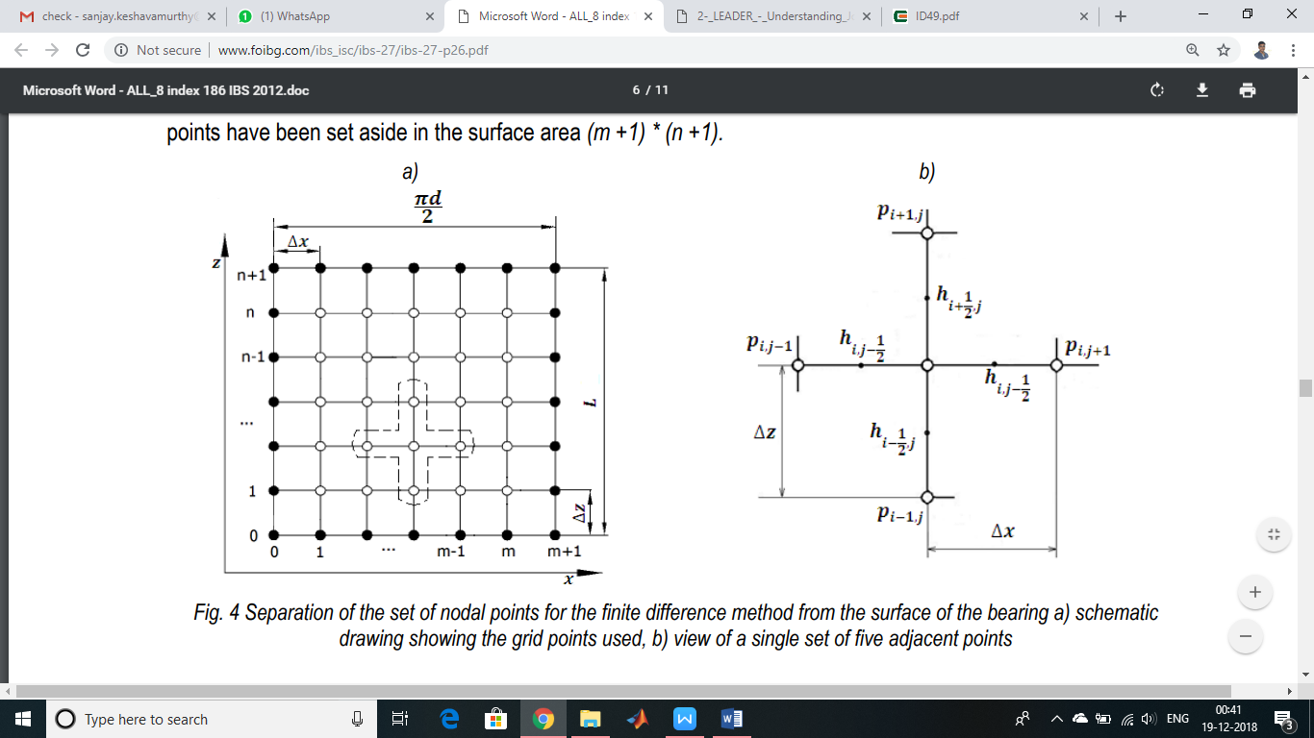

Figure 2.6: Nodal points used in FDM

The most important advantages of FDM:

* differential equation of any kind (ordinary, partial, linear, nonlinear) can be solved
* heterogeneity of material can be taken into account
* it is conceptually simple and uncomplicated to implement on a computer,
* it generates a set of equations which is characterized by the unique matrix that allows using of fast iterative methods for solving this set of equations.

The main disadvantages are:

* difficult to solve for irregular geometry cases
* it can lead to large errors for too coarse grid and to a huge number of nodes and unknowns for too fine mesh leads,
* although there is a possibility of the local density of mesh nodes, it greatly complicates the installation of the equations themselves,
* it is probably not suitable for solving the field equations in unlimited areas because it requires the imposition of a finite number of nodes to a grid area

Mathematical writing of Reynolds theory is based on principles: the conservation of mass (continuity equation) and momentum (Navier-Stokes equation). Reynolds equation is a partial differential equation of second order, inhomogeneous, linear. It is impossible to solve this equation by analytical determination. Reynolds’ analysis and his mathematical record of pressure distribution in oil film became the foundation for further development of the theory of hydrodynamic lubrication. For the purposes of getting numerical solution of Reynolds equation, it is brought to dimensionless form.

Hence the Reynolds Equation is solved by Numerical Methods. For finding the pressure at any node, pressure values at all the surrounding nodes must be known from the previous iteration. Thus, a pressure v/s θ v/s z plot is obtained. From the pressure values the load carrying capacity is obtained.

**Chapter 3**

**Methodology - Derivation of Reynolds Equation**

**3.1 Assumptions**

* Negligible inertia terms
* Negligible change in film thickness in z direction i.e. h varies with only θ
* Newtonian Fluid
* Constant coefficient of viscosity (η=constant)
* No slip of liquid solid Boundary
* Neglecting angle of inclination for the coordinate system
* Compressible but ideal gas flow
* Relative tangential velocity in x – direction
* Both the surfaces are rigid, i.e. no stretching action
* Top surface is stationary
* Film Thickness, h is a function of only pressure ‘p’, θ but not z

Steady state operation of bearing or in other words film thickness does not change with time*.*

Considering a finite volume inside the bearing, we apply and equate the forces in different directions:



Figure 3.1: Forces applied on a control volume in the bearing

In the above diagram,

is representation for

is representation for

is representation for

Balancing the forces in x direction we get, (Assumption 1: inertia terms are negligible)

i.e. 3.1

For laminar flow of Newtonian fluid, (Assumption 2, Newtonian fluid)

3.2

From equations 3.1 and 3.2, we get

3.3

Assumption 3: Negligible pressure gradient in direction of film thickness, y direction

Assumption 4: Coefficient of viscosity, is constant

3.5

i.e. 3.6

Similarly force balance in z direction we get

3.7

Integrating equation 3.6 we get

3.8

3.9

At y=0, and

At y=h,

Assumption 5: Assuming no slip at liquid solid boundary,

I.e. liquid has same boundary as the solid plate

3.10

3.11

Solving the above we get

3.12

Here is the pressure term

While are the two velocity terms, and being the maximum and minimum velocity respectively.

Similarly in z direction we get,

Similarly in z direction,

3.13

Hence on integrating the continuity equation

3.14

⇒ 4.25

⇒

In the above equation:

Left hand side terms are the PRESSURE TERMS

Right hand side terms are the SOURCE TERMS

and are the WEDGE TERMS

and are the STRETCHING ACTION TERMS

is the SQUEEZE ACTION terms

Also the squeezing action term can be written as

3.15

Thus the Reynolds equation comes out to be

3.16

However for performing more real world situation, our research work consists of compressible lubricant that is density is not a constant, thus assumption 7 is cancelled.

Hence the Reynolds equation under compressible condition comes out to be

3.17

Assumption 8: Relative tangential velocity only in x direction and not in z direction

3.18

Assumption 9: Both surfaces are rigid or in other words no stretching action

⇒ 3.19

Assumption 10: The top surface is stationary or

Assumption 11: Steady state operation of the bearing

3.20

Thus the Reynolds equation taking into account all assumption is:

3.21

**3.2 Case 1: Journal bearing without bumps:**

On making the modifications to the Reynolds equation, we get

On applying the taylor series and FDM,

f(x+Δx)= f(x)+ Δx. f| (x)+ Δx2 /2! . f|| (x) +…

f(x-Δx)= f(x)- Δx. f| (x)+ Δx2 /2! . f|| (x) +…

The pressure terms will become,

Pi+1 = Pi + Δx Pi| + Δx2 /2! . Pi ||+…..->truncation errors

Pi-1 = Pi - Δx Pi| + Δx2 /2! . Pi ||+…..

Pi| =

Pi| =

🡪[ i,j+0.5 p̅3 i,j+1 + i-0.5,j p̅ 3 i-1,j - (i+0.5,j + i-0.5,j ) . p̅ i,j] / (Δx)2

🡪[ i,j+0.5 .p̅3 i,j+1 + i,j-0.5 p̅ 3 i,j-1 - (i,j+0.5 + i,j-0.5 ) . p̅ i,j ] / (Δz)2

[ i+1,j - i-1,j ] / 2Δx

p̅ 0 i,j = 0

**p(I,J) = A* p(I,J+1) + A* p(I,J-1) + C* p(I+1,J) + D* p(I-1,J) - E;**

**3.3 Matlab code:**

N = 50;

M = 50;

C = 0.5;

Z1 = 50;

X1 = 25;

delxbar = 1/N;

delzbar = 1/M;

const1 = X1*X1/(Z1*Z1);

ITER = 100000;

for I = 1: N+1

for J = 1: M+1

p(I,J) = 0.0;

end

end

sum(1) = 0.0;

for K =1: ITER

sumij = 0.0;

for I = 2:N

X(I) = 1/N*(I-1);

h = 2/3*(2-X(I));

hm = 2/3*(2-X(I)-0.5*delxbar);

hp = 2/3*(2-X(I)+0.5*delxbar);

hm1 = 2/3*(2-X(I)- delxbar);

hp1 = 2/3*(2-X(I)+delxbar);

cubh = h*h*h;

cubhm = hm*hm*hm;

cubhp = hp*hp*hp;

const2 = (cubhp+cubhm+2*const1*cubh);

A = const1*cubh/const2;

C = cubhp/const2;

D = cubhm/const2;

E = -0.5*delxbar*(hp1-hm1)*C/(const2*X1);

for J=2:M

Z(J) = 1/M*(J-1);

p(I,J) = A* p(I,J+1) + A* p(I,J-1) + C* p(I+1,J) + D* p(I-1,J) - E;

sumij = sumij + p(I,J);

end

end

sum(K+1) = sumij;

percentage = abs(sum(K+1)- sum(K))/abs(sum(K+1));

if percentage < 0.0001

break

end

end

y = K

surf(p);

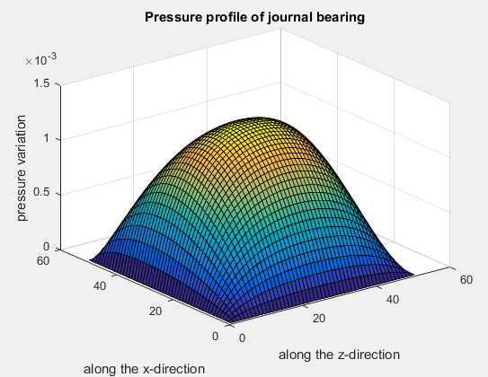

Fig 3.2: Pressure profile

**3.4 Case 2: Journal Bearing with Bumps placed:**

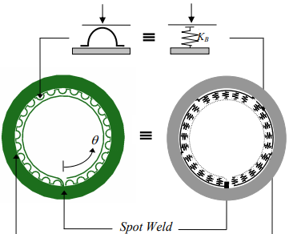

Fig 3.3: Bumps act as spring

**3.4.1 Relation for oil film thickness:**

The film thickness is given by the relation:

But, since our bearings is of compliant nature, the film thickness is also dependent upon the pressure

Or

Again, normalizing the above relation, we get,

Where

Also is known as the compliance number of the bearing and is given by the fallowing relation

Compliance number

**3.4.2 Reynold’s Equation in Polar Coordinates:**

The Reynolds Equation in Cartesian equation is given by:

3.22

While considering only one bump structure for pressure distribution then pressure and film thickness is independent on axial direction i.e. z-axis.

Hence equation 3.37 written as

3.23

Using polar coordinate, the two important transformation equations are:

1. ⇒

2.

Where R = Radius of journal

w = Angular velocity of journal

r = Distance along the radial direction, changes from Centre of journal to bearing sleeve

, U=wR

The final equation in polar co-ordinates is

**3.4.3 Normalisation:**

**3.4.4 Numerical Methods:**

Our next target is to solve the Reynolds Equation:

The Reynolds equation is converted into the finite difference from using certain Finite Difference Approximations:

This is the final equation to be solved in MATLAB

**3.4.5 Mat-lab code:**

c=0.5;

L=50;

R=25;

e=0.3;

s=10;

thick=0.1;

pa=0.1;

v=0.3;

n1=0.6*10^-6;

w=2000/60;

Eb=200000;

alpha=(2*pa*s*(1-v^2))/(c*Eb*thick^3);

Er=e/c;

B1=(6*w*n1/pa)*(R/c)^2;

n=50;

m=50;

dt=(2*pi)/n;

dr=c/m;

iter=100000;

l=linspace(0,50,50);

r=linspace(0,c,50);

t=linspace(0,2*pi/50,50);

theta=2*pi/36;

r1=c;

for i=1:n

for j=1:m

p(i,j)=1.0;

end

end

sum(1)=1.0;

for k=1:iter

sumij=0.0;

for i=2:n-1

h=1+Er*cos(t)+(-2+alpha/c*(1.5*pa*p(i,j)-1)); %-h(i,j)

h1=1+Er*cos(t)+alpha/c*(pa*p(i,j)-1)-0.5*dr; %-h(i-0.5,j)

h2=1+Er*cos(t)+alpha/c*(pa*p(i,j)-1)+0.5*dr; %-h(i+0.5,j)

h3=1+Er*cos(t)+alpha/c*(pa*p(i,j)-1)-dr; %-h(i-1,j)

h4=1+Er*cos(t)+alpha/c*(pa*p(i,j)-1)+dr; %-h(i+1,j)

h5=1+Er*cos(t)+alpha/c*(pa*p(i,j)-1)-0.5*dt; %-h(i,j-0.5)

h6=1+Er*cos(t)+alpha/c*(pa*p(i,j)-1)+0.5*dt; %-h(i,j+0.5)

h7=1+Er*cos(t)+alpha/c*(pa*p(i,j)-1)-dt; %-h(i,j-1)

h8=1+Er*cos(t)+alpha/c*(pa*p(i,j)-1)+dt; %-h(i,j+1)

cubhm=h1.*h1.*h1;

cubhp=h2.*h2.*h2;

cubhm1=h5.*h5.*h5;

cubhp2=h6.*h6.*h6;

a1=theta^2*dr^2;

a2=r1*theta*dt*dr;

a3=r1^2*dt^2*100;

a4=1/(theta*dr)+1/(r1*dt);

a5=1/(theta*dr)-1/(r1*dt);

const=(cubhp/dr+cubhp2/dt)*a4+(cubhm/dr+cubhm1/dt)*a5;

A= (h2/a1+h6/a2)/const;

B= (h2/a2+h6/a3)/const ;

C= (h1/a1+h5/a2)/const;

D= (h1/a2+h5/a3)/const;

E= ((h3-h4)/(2*theta*dr)+(h7-h8)/(2*r1*dt))/const;

for j=2:m-1;

p(i,j)=A*p(i+1,j)+B*p(i,j+1)+A*p(i+1,j)+C*p(i-1,j)+D*p(i,j-1)+E;

sumij=sumij+p(i,j);

end

end

sum(k+1)=sumij;

percentage=abs(sum(k+1)-sum(k))/abs(sum(k+1));

if percentage<0.00001;

break

end

end

y=k;

P=max(p);

%Plots of pressure profile Film thickness %

figure(1);

surf(p)

figure(2);

[X,Z]=meshgrid(t,r);

mesh(t,r,p)

title('Pressure profile of journal Foil bearing ');

xlabel('along one bump(2*pi/50)');

zlabel(' pressure variation');

ylabel('along the radial clearnce')

figure(3);

plot(t,h,'-k');

title('The variation of film thickness in circuferential direction')

xlabel('Theta in radian along one bump');

ylabel('film thickness in mm)');

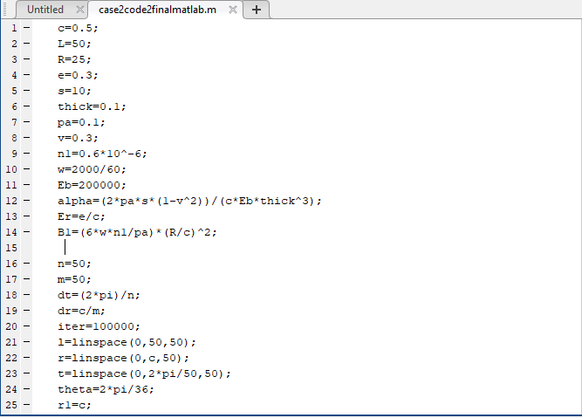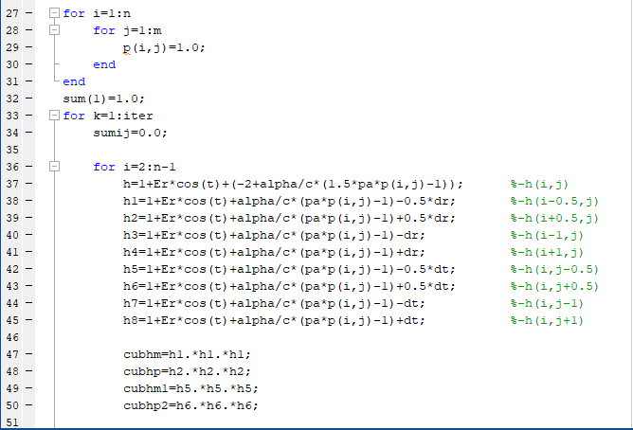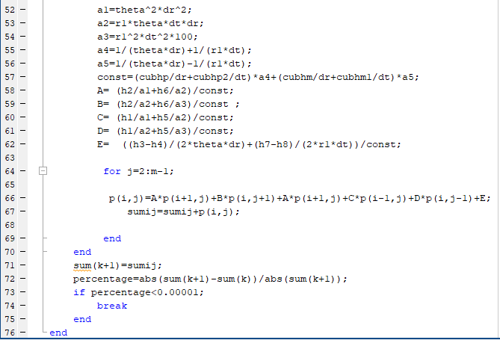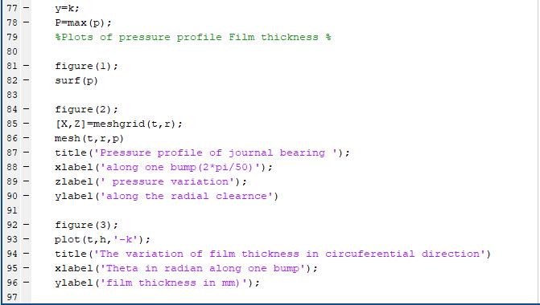

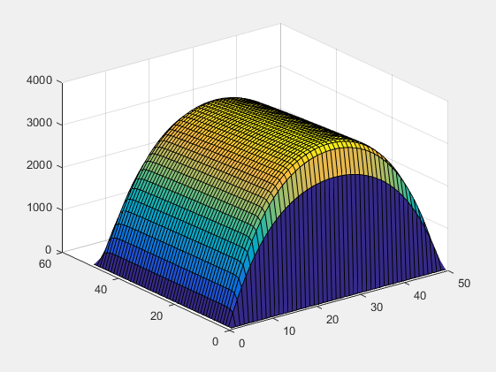

Fig 3.4: Pressure profile for complete bearing

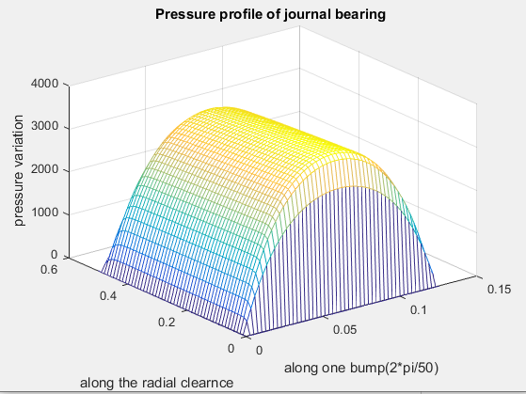

Fig 3.5: Pressure profile for single bump

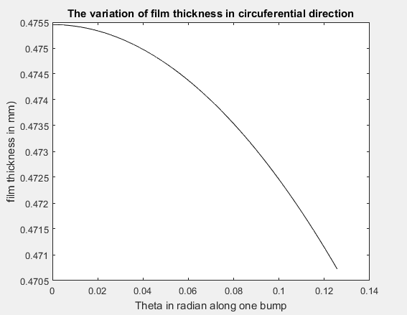

Fig 3.6: Variation of Film thickness

### 3.4.6 Energy Dissipation: -

The energy balance of a frictional dissipative system can be written as follows:

Eu + Ek + Ek – Ew= Cte

In finite difference codes, all the components of the energy are usually available for the whole model. As expected, due to the small mass of steel foils, the kinetic energy EK is very low, which means it can be neglected in a further analytical model. The below graphs clearly depict the significance of the energy lost due to friction and responsible for dissipative capacity of the foil structure. Three types of mechanical dissipation are present in an elastic structure:

1. Viscous damping, where the damping force is proportional to the velocity

mx¨ + cx˙ + kx = f(t)

1. Structural or hysteretic damping, where the damping force is internal to the material

mx¨ + k* x = f(t)

1. Coulomb friction damping, where the damping force is proportional to the normal load

mx¨ + kx = ft − gN sin(x)

1. Very little viscous damping is present in steel foil structures. The structural damping of steel shells is also likely to be negligible compared to friction damping. It then follows that all the damping in the FE model is due to friction. Although the physical causes of these three dissipation mechanisms are different, it is possible to mathematically relate the energy dissipation due to friction to a viscous or structural damping system with the same dissipative capabilities 30. This is convenient for introducing the dissipative characteristics of the elastic structure in a foil bearing code.

The energy dissipated in one cycle for a system with all types of damping is

Wcycle = = kγπ X2

The motions of a structurally damped system with harmonic excitations are themselves harmonic. One can thus rewrite the equation obtained is

mx¨ + k x˙ + kx = f(t)

The analogy with viscous damping allows the definition of an equivalent viscous damping coefficient Ceq=kγ/w and the energy dissipated for one cycle is written as follows:

Wcycle = kγX2 π

The Coulomb damping is a nonlinear phenomenon due to the sign function and can be expressed as follows:

mx¨ + fnlx˙ + kx = f(t)

In this case, at least from theoretical standpoint, the motions issued from harmonic excitations are not necessarily harmonic.

Stiffness Coefficient and Damping Coefficients are given by:

* Stiffness Coefficient,
* Damping Coefficient,

Where

= Phase angle in Degree

Angular frequency rad/s

= Shaft vertical displacement in m

**3.4.7 Calculation of energy dissipation:**

1. Angular velocity = 2* π *N/60

= (2 * 3.14 * 14000) / 60

= 1466.07 m/sec

1. Excitation frequency= /2* π

= (1466.07)/ (2 * 3.14)

= 233.45 Hz

1. Force

= 60*10-3 * 1466.072 * 0.02 * 10-3

= 2.57

1. Stiffness Coefficient,

= (((2.57 *cos 36.686) / 0.024) + 4 * 1466.072) * 0.01

= 86.83 KN/m

1. Damping Coefficient,

= ((2.57 * sin 36.686) / (1466.07 * 0.024)) * 0.01

= 18.66

1. Energy dissipated E = k*γ*π\**x*2

**=** 86.83 * 0.315 * 3.14 * 0.0242

**=** 0.0428 N-mm

**Chapter 4**

**Results and Discussion**

**4.1 Table of results:**

|  |  |  |  |  |  |  |
| --- | --- | --- | --- | --- | --- | --- |
| Speed (N) RPM | Angular velocity (m/sec) | Excitation frequency (Hz) | Force | Stiffness (KN/m) | Ceq | Energy dissipated (N-mm) |
| 13000 | 1361.36 | 216 | 2.224 | 74.84 | 17.3 | 0.0428 |
| 14000 | 1466.07 | 233 | 2.57 | 86.83 | 18.66 | 0.0494 |
| 15000 | 1570.8 | 250 | 2.96 | 100 | 20 | 0.0572 |
| 16000 | 1675.5 | 266 | 3.36 | 113.41 | 21.328 | 0.0642 |
| 17000 | 1780.23 | 283 | 3.803 | 128 | 22.6 | 0.0731 |
| 18000 | 1884.9 | 300 | 4.26 | 143.5 | 24 | 0.081 |
| 19000 | 1989.6 | 316 | 4.75 | 159.9 | 25.3 | 0.091 |
| 20000 | 2099.4 | 333 | 5.26 | 177.21 | 26.6 | 0.113 |

**4.2 Graphs Plotted:**

**1). Energy dissipated vs Ceq:**

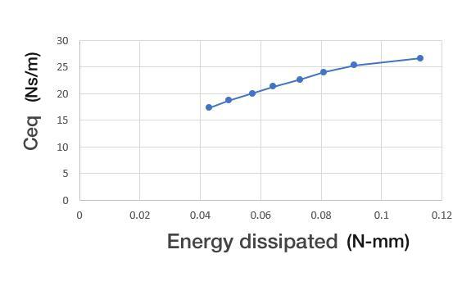

### 2).Excitation Frequency vs Stiffness:

### 

**3). Excitation Frequency vs Energy dissipated:**

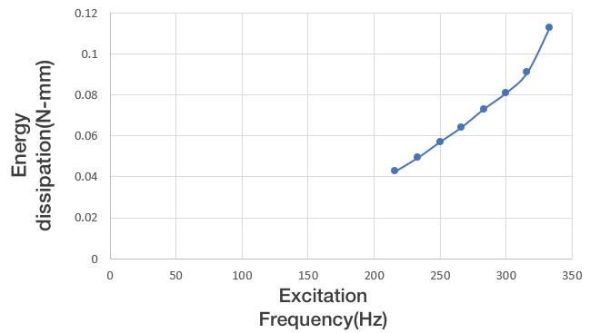

**Chapter 5**

**Applications**

1. Compliant foil bearings operates at high speed with an insignificant steady state rotor weight while dynamic forces (internal and/or external shock and vibration) exceeding steady loads by an order of magnitude, especially they are used in the high speed turbo-machines.

2. A turboexpander, also referred to as a turbo-expander or an expansion turbine, is a centrifugal or axial-flow turbine, through which a high-pressure gas is expanded to produce work that is often used to drive a compressor or generator.

3. The compliant bearing with flexible top plate surface and elastic support has excellent resistance against rotor inclination under extreme environments and excellent resistance against eddy motion at high speed. The highly effective and stable operation of a cryogenic expander is of great significance.

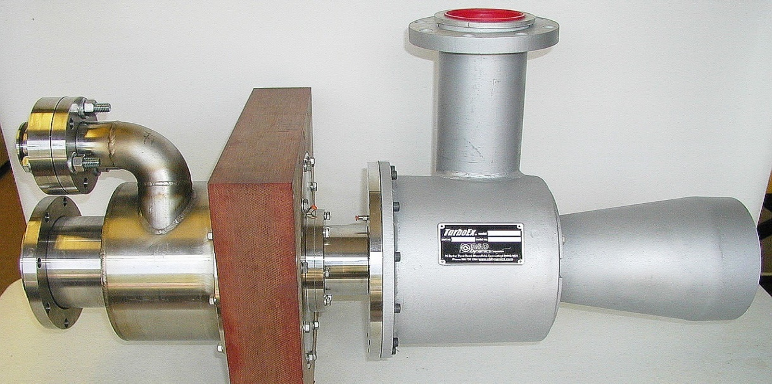

Fig.6.1: Cryogenic turbo expander

**Chapter 6**

**Conclusion**

Reynolds equation is modified for two cases, i.e. by placing bumps and without placing it. It is modified using normalization technique and finite difference method and related graphs are obtained. For the above cases, pressure distribution is analysed and we obtain a result of higher pressure in the case of bumps placed. Energy dissipation is calculated in each case and the respective graphs are obtained. This infers that by placing the bumps the load carrying capacity and damping is increased, thereby achieving the controlled vibrations.

The complexity of tribological phenomena is so large that without the use of computer technology it is difficult to make any research in this area. Computer technology that uses advanced numerical methods is a supportive tool, in many cases it allows to carry out modelling and simulation of complex tribological occurrence which take place in different nodes and different working conditions.

**Comparison of results:**

|  |  |
| --- | --- |
| **Without Bump** | **With Bump** |
| Pressure value = 800Mpa | Pressure value = 2500Mpa |
| Damping is less. Hence vibrations are more. | Vibrations are controlled because of increase in damping |
| Energy dissipated is less | Energy dissipated is more because of higher damping by placing bumps |

**References**

1. Campbell, W.E. (1969). “Boundary Lubrication: An Appraisal of World Literature.” ASME.
2. Shims Robert Hoffmann1 Tomasz Pronobis1 Robert Liebich SIRM 2015 – 11th International Conference on Vibrations in Rotating Machines, Magdeburg, Deutschland, 23. – 25. February 2015 A numerical performance analysis of a gas foil bearing including structural modifications by applying metal
3. P. N. Nagare Department of Mechanical Engineering, Amrutvahini College of Engineering Sangamner, India

A Comparative Study on Numerical Solution of Reynolds Equation of Journal Bearing

1. Malcolm E. Leader, P.E Co. Durango, Colorado, Applied Machinery Dynamics Understanding Journal Bearings
2. L. P. Alford, McGraw Hill, The American Machinist, 1911 Bearings and Their Lubrication
3. Wiesław Graboń, Jan Smykla, Computer program for simulation of pressure distribution in the hydrodynamic radial bearing
4. D. Sfyris a, A. Chasalevris b, University of Aegean, Aegean 81400, Greece

An exact analytical solution of the Reynolds equation for the finite journal bearing lubrication

1. https://www.tandfonline.com/doi/abs/10.1080/10402004.2010.538490